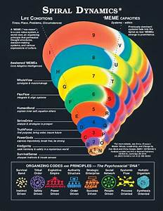
Unity of Pomona Valley’s Talk Topics Series January 2025- Spiral Dynamics
From Jan Chase 909-896-0991

January 5: Burning Bowl – Burning thoughts and behaviors we have evolved out of that no longer serve us well.
Understanding our spiraling evolutionary process.
Listen: https://www.youtube.com/watch?v=BdawYHI_X1Y Holistic view
Listen: https://www.youtube.com/watch?v=Oos-sruxgFI Tier One individual and historical view
Listen: https://www.youtube.com/watch?v=gaWzEQg5gqY Tier Two -Exploring authenticity and
Read if interested: https://awaken.com/2020/04/ken-wilber-summary-of-spiral-dynamics-model/ Ken Wilber’s explanation.
Read if interested: https://deep-psychology.com/ken-wilber-spiral-dynamics/ Limitation of SD per Ken Wilber
https://www.spiral-dynamics.com/faq_levels.htm NVC on Spiral Dynamics
https://deep-psychology.com/what-is-spiral-dynamics/ Views of Life: Life is…It’s sensible to…

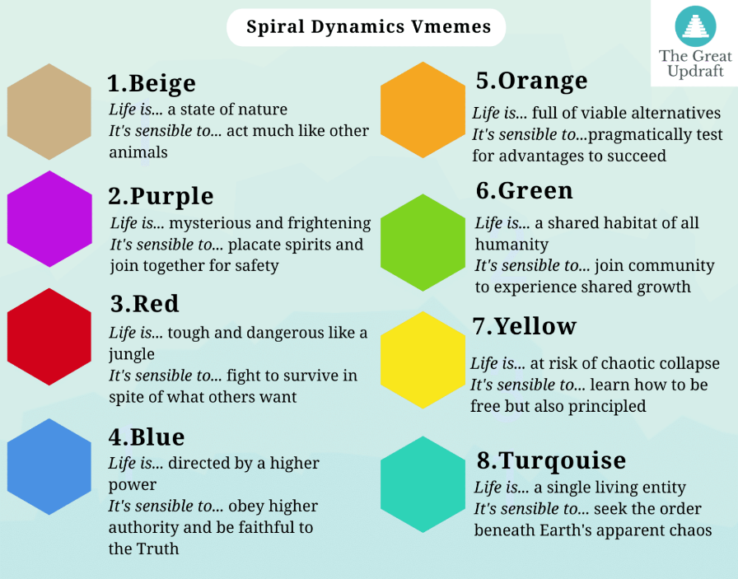
First Tier: explores physical realm
Beige (individual): a state of nature for survival, physical, instinctual. Lowest level of consciousness, food water warmth sex and safety, herd instinct. Babies, crisis, recovering from illness, early humanity,
Purple (Group consciousness): mysterious and frightening…placate spirits and join together, focus on survival, safely and security in a group, believed in magical spirits, ie. Sun god, fear of thunder, appease spirits, community to survive. Religions started ritual started. Respect for elders, group pride. Relationship to magic. Animistic religions. Early tribes. Not contemporary.
Red (Individual consciousness): rough and harsh, fight to survive in spite of others, focus on ego and power, instant gratification, individualist, no guilt and shame, toddlers and teens, Want to be myself, individual self, courage, personal glory. Warring cultures, legendary hero worship.
Blue (Group consciousness): divinely controlled and purposeful, obey authority, sense built. Do right, focus on order, differences between right and wrong, care about judgements, conservative and conventional, Structure, rules, safety. Heirarchial ie church, nation, knowing role and doing it well. History: government, religions, cities.
Orange (Individual consciousness ): full of alternatives and opportunities, test options for greatest success. Focus on success and prosperity, materialism, capitalism, corporatism, money, and human rights, innovative, logic, personal achievement, what makes one feel happy. History, science and business.
Green (Group consciousness): shared habitat of all humanity, join community and grow personally. Focus on community, equality, environmentalism, Peace, sharing resources, rejecting power structures, developing vulnerability, awareness of inner and outer self. Discover power of service and spirituiality. History: recent. All different. Focus on social justice and socialized health care.

Second Tier. Knowledge and building, explore spiritual realm
Yellow (Individual not selfish): complex system in danger of collapse, explore ways of being responsibly free, synergy, learning, flexibility, building complex systems that work easily, creativity. Sees interrelatedness, find life purpose. Intuition. Aligning the selves. Search for truth. Amass knowledge. No attachment to being right. Seeing into opposite fields. History: EU? Example.
Turquoise (Group cosmos): delicately balanced interlocking forces, experience ways to re-order life’s chaos. Harmony, holistic things, wholeness, cosmos, mind and spirit, holistic wellness, Other layers of reality. Knows impossible for left brain to know and understand Truth. Trust inner guidance, Distrust conscious mind, left brain knowledge. Have clear access of inner guidance for everything. Experience everything as conscious ie rocks, trees, connect and communicate with all and all people and cosmos. Magical and mystical experiences. Symbiotically holistic includes all stages of consciousness.
Coral (Solitary but fractal experience of self/group): unfolding after post-turquoises conditions arise. Urge to clean up the self, shadow work. No self and non-reality. Power to change ego. Feels less real. What cared about before, not important. Doesn’t matter what I do. Subtle abilities. Causal states.
Teal: No longer id’s with ego. Surrenders to divine purpose. Not afraid of death. Know manifest reality isn’t real. Sense that only real thing to do in life is to follow divine plan that can’t understand with left brain. Willing to die. Sense that nothing is a problem anymore. All problems created by personality which is deconstructed. Constant connection with divinity experienced as love. Has unconditional love experience. Mystical ability, witnessing states of divine love. Willingness for everything. Witnessing state, loving and joyful. More profound than emotions, profound. Feels clear and open. (Laura?)
Plum: Crystal clarity, feeling of freedom. Immediate inner knowing. Becoming source of knowing. Confidence, not ego. Becoming who truly am.
Aubergine: rare. Involves total surrender of last vestiges of individual will. Serve Consciousness is goal. No idea a bout what doing or why. No self left. Or Self much bigger, integrated or whole. Self integrated and multifacted. Motivated to serve Consciousness. (Shores of infinity- Chris.)

We fit into all, more in one stage than other. Life is cyclical, can move up and down.

